Inuit Masks

Referring to native Arctic people in Alaska, Canada, and Greenland, the name “Eskimo” is now thought to be a reference to snowshoes. Eskimos in Canada and Greenland now generally prefer to be called Inuit. Although Inuit masks were often burned or otherwise destroyed after use in ceremonies and dances, many masks have been found originating as early as the 18th century and into the 20th century.

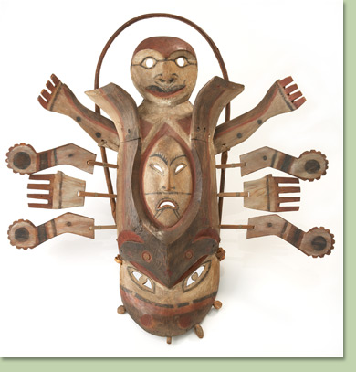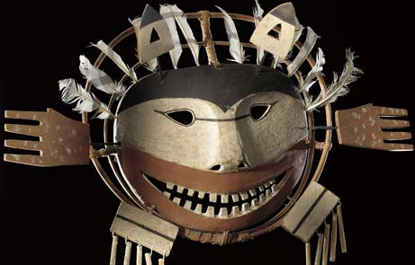

Mask, Yup'ik
early 20th century
driftwood, spruce root,
metal

Yup'ik masks made the invisible visible. They are the physical representations of encounters with the spirit world. Spiritual leaders design the masks to represent beings they have seen while in a trance. Every element and motif of a mask has a special purpose, the meaning of which is known only to the creator of the mask. The mask on the right represents the spirit Amekak, which is said to live in the ground.

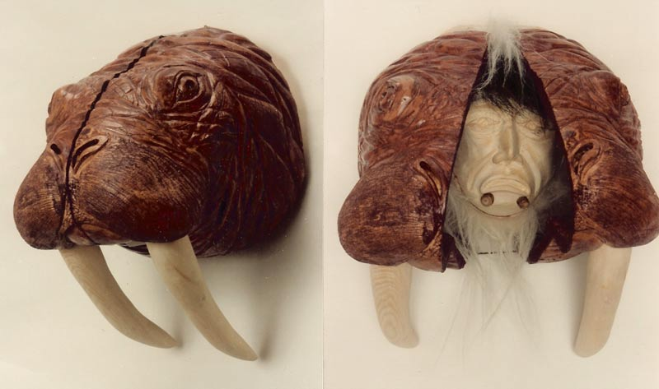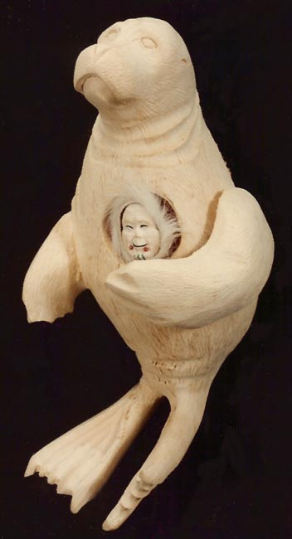

The mask on the left is a very realistic rendering of a walrus. When you open the mask, it transforms into the hunter who seeks the walrus. The mask on the right is a seal done in the Eskimo style, however when the arm of the seal is moved the inua or spirit of the seal is seen. The spirit of the seal is carved of ancient walrus ivory and has a ruff of mountain goat hair and labrets of authentic trade beads. The mask may be depicted or stained in a natural finish.
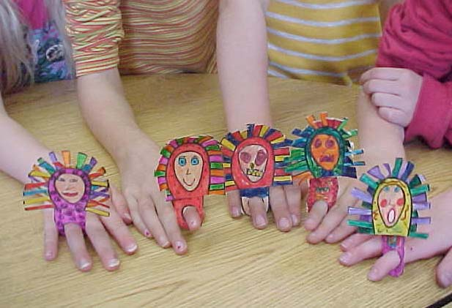

Inuit Finger Masks: Mask-making is a traditional Inuit craft. Masks are used in ceremonies and Eskimo festivals. The Inuit people live in northern Canada, Greenland, Alaska, and Siberia. Often women dancers wear little finger masks, which are carved out of wood and may have feathers on them. The women wave their hands around during the
dance and move to the rhythm of the music.

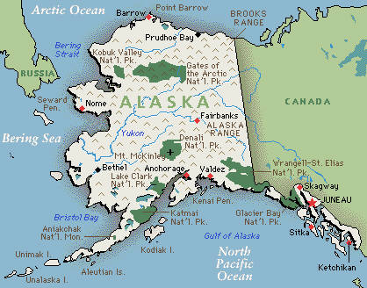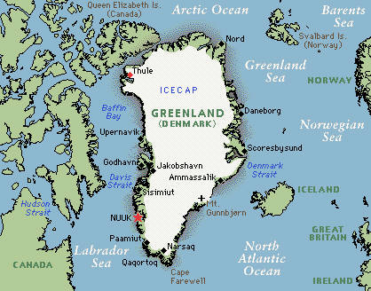

Test Questions:
- Name the main region where the Inuit people live, identifying at least three more specific locations included in this region (state, country, body of water, etc.)
- Name two subjects depicted in the Inuit masks.
- Describe at least three formal qualities that are characteristic of Inuit masks.
- What is the primary function of the masks in relation to Inuit culture?
- List at least four materials used to create Inuit masks.

Created by Jeri Kelly

